**ENERGY EFFICIENCY IN THE   
AUSTRALIAN INDUSTRIAL SECTORS**

Executive Summary 2

Introduction 4

Investment in Energy Efficiency: Business Decision-making 5

Considerations behind Investment Decisions 5

Energy Efficiency Improvements in Australian Industrial Sectors 8

Manufacturing 9

Alumina & Aluminium Industries 9

Upstream Oil & Gas Industry 11

Electricity Generation Industry 12

Framework Principles for Future Energy Efficiency Policy 16

Conclusion 19

# Executive Summary

Energy is a crucial input into production processes for many Australian industries. Australia’s economy includes a range of industries that have developed here due to the availability of, and access to, competitively priced energy and resources.

Australian Industry Greenhouse Network (AIGN) members believe that, in most circumstances, market forces lead to the most efficient use of resources and, as a principle, Australian companies should operate with minimal regulatory intervention related to energy.

Industrial emissions intensity within Australia has improved over recent years in response to rising energy prices, which have triggered decisions and investment to improve profitability (and, in many cases, result in energy efficiency gains). This paper outlines the investment by industry in energy efficiency improvements, noting the key drivers for such investments and the nature of investment decision-making at the firm level. Decisions on investments around energy use are one of many that a firm will need to balance with regard to any investment options requiring capital to realise.

Focussing on energy efficiency whilst ignoring other important inputs will not necessarily result in the most efficient use of energy resources. Furthermore, such an approach ignores the underpinning profitability of a business and is therefore unviable. Investment (and hence production) decisions are driven by the combined costs of all inputs and best reflect a firm’s perspective of the economic environment and their competitiveness within it. Large energy producers and users, including export and import competing companies, have complex decision-making processes and need to weigh a wide range of factors; energy efficiency outcomes are just one such factor.

This paper highlights the array of internal metrics that a firm must consider in making an investment decision. A business considering investing in new technology will evaluate not just its financial costs and energy consumption, but also how well the equipment will do its intended job, its potential integration within existing production processes, additional training and maintenance requirements, safety considerations, and a range of other factors.

Focussing on energy efficiency in isolation assumes that there is a direct correlation between energy consumption and profitability, which often is not the case. It is important for companies to balance a range of considerations (including regulatory) to enhance shareholder value.

Finding and implementing energy savings is not costless. The net return from such an investment must not only meet internal hurdle rates, but also compete with alternate applications of capital and resources, and often in competition with business units in other countries.

There are a wide range of risks and issues to consider as part of the decision-making with respect to investment in energy efficiency measures, including:

* Future energy costs
* Security of the business
* Forward revenue stream
* Economic trends and future Government policy
* Commodity prices
* Cash flow
* Technical risks including equipment failures/shutdowns (lost output, unscheduled maintenance, deployment of labour)

A policy that narrowly focuses on reductions in the use of energy implies that the use of one factor of production (energy) is minimised without sufficient regard to the corresponding cost trade-offs. Economic efficiency relates total costs to the value of the output that those costs generate, and it is this metric that underpins decision-making in business. It is rare that a decision to minimise the use of one input (ie. energy) at the expense of all others, is economically efficient.

Limits to improvements in energy efficiency are real and not simply information failures. Companies are focussed on the efficiency of capital in an environment where there are limits on the capital available for investment, and hurdle rates for energy efficiency investments are set to reflect process disruptions, risks to achievement, and resources required.

AIGN has recommended the development of a national approach towards climate change policy that is consistent with other policy objectives such as the economy, employment, trade, investment, technology, environment and regional and rural development. . Intervention should only ooccur where there are clear instances of market or information failure. It is imperative that state and territory policies are well aligned with the national policy to maximise benefits and minimise compliance costs. AIGN has recommended a set of principles for the development of such a national energy efficiency policy.

From industry’s point of view the formula for a step change in energy efficiency is relatively straightforward:

***A competitive industry = a profitable industry***

***A profitable industry =investment and replacement of capital stock***

***Investment = new energy efficient technology***

***New technology = step-change in energy efficiency***

AIGN members remain willing to work with governments to further develop these ideas.

# Introduction

Australia’s economy is led by a range of industries that have developed here due to the availability of, and access to, competitively priced energy and resources. Indeed, our natural resources advantage underpins our prosperity. Energy costs have, however, increased substantially in recent years, and this has further heightened the commercial incentive for organisations to minimise their energy use in order to save money. Consequently, examining the cost-effective use of energy is an indispensable part of business management that both large energy producers and large energy users undertake as a matter of course.

This paper examines the current drivers and limitations for the adoption of energy efficiency measures in the Australian industrial sectors, and outlines framework principles for government policies designed to promote further investment in energy efficiency as part of a greenhouse gas (GHG) mitigation program. The World Energy Council defines energy efficiency as *“the energy used for a given service or level of activity”*, (“World Energy Perspectives: Energy Efficiency – what works and what does not” September 2013) whilst the Productivity Commission provided a similar definition of energy efficiency as being the *“output per unit of energy input*” Inquiry into the Economic and Environmental Potential of Energy Efficiency 2005) . Drawing on examples from AIGN members, this paper highlights why investment in energy efficiency is fundamentally a business decision that is impacted by a wide range of considerations.

AIGN members are industry associations and corporations operating in a wide range of industrial sectors (including both energy producers and large energy users) and collectively account for about 70% of Australia’s GHG emissions. Many are classified as emission-intensive and trade-exposed (EITE) businesses.

As a principle, AIGN advocates that Australia’s greenhouse policy measures should be based as far as practicable on market measures and underpinned by streamlined, efficient and effective monitoring, reporting and verification (MRV) compliance arrangements. Australia now has considerable experience in MRV associated with energy use and GHG emissions, and is recognised as a world leader with very high benchmarks. Many parts of Australian industry have been externally reporting their energy use and GHG emissions for nearly 20 years via voluntary programs such as Greenhouse Challenge, and on a compliance basis since the National Greenhouse & Energy Reporting (NGER) Scheme was introduced in 2007. We recognise, however, that government does have a role when markets are unable to deliver competitive economic and/or favourable social outcomes. In such circumstances, we suggest that there should be a clear net benefit to the Australian economy, so that the cost of regulation does not outweigh the benefits.

Although many constraints to energy efficiency investment can be identified, some reflect the rational decision-making of energy users and do not of themselves represent market failure. Importantly, energy is not considered in a vacuum by industry, but as one of a range of factors contributing to performance and profitability. As a general rule, higher energy efficiency equals better performance and profitability, but this does not mean that every opportunity to invest in energy efficiency should, or can, be realised.

Energy is only one of the key factors used in the production process, along with labour, capital, other resources, technology, etc. Australia’s industrial base is relatively energy-intensive, primarily owing to past access to comparatively cheap, reliable energy. Historically, the cheap and abundant energy supply created a competitive advantage for Australian operations and helped to offset the disadvantages of a small market, relatively high wages, and Australia’s distance from major markets.

As investment in energy efficiency is fundamentally a business decision, the success of policies and strategies to promote greater uptake of energy efficiency measures will depend primarily on the business case for such investments. Businesses have adapted to various policy and other changes. Rising energy costs and the pressures of global competition pose continuing challenges for industrial extraction and manufacturing sectors. In order to maintain the international competitiveness of Australian industry, it is critical that the national policy framework provides the right environment for large industrial operations to continue to invest in Australia.

# Investment in Energy Efficiency: Business Decision-making

## Considerations behind Investment Decisions

Investment, and hence production decisions, are driven by the combined costs of all inputs and best reflect a firm’s perspective of the economic environment and their competitiveness within it. Investment decisions within the industrial sector are largely based on being able to secure long-term, competitively-priced supplies of raw materials, energy and labour. Decisions by business on capital investment, which take time to mature and are typically large (as compared to current expenditure), have to be based on predicted returns and meet a range of other key business priorities.

The key principle in evaluating energy efficiency opportunities is that the investment must increase overall corporate value. As such, it must also be consistent with long-term strategic goals.

When designing new processes or updating equipment, each AIGN corporate member considers energy efficiency in accordance with their sustainability or environmental policy, with such policies consistently focussing on improvements with respect to energy use, resource consumption, emissions, waste, discharge and ecological footprint. As part of their decision-making, companies must also ensure that processes and changes to equipment meet safety, health, economic, operational and environmental criteria.

In response to some commentary that a lack of internal capital is the major impediment to investment in energy efficiency, it should be noted that while capital is constrained in many situations, the real issue is in prioritising the capital (‘capital efficiency’). Businesses are not homogenous, and what makes sense for one business may present different costs and benefits to another business in terms of energy efficiency. Firms must have regard to many other considerations ‑ product quality, market conditions and level of demand, marketing, competitors’ actions, other production inputs, occupational health and safety, to name a few ‑ not just the benefits and costs of greater energy efficiency. If improving energy efficiency is foregone in favour of other more cost-effective opportunities, this is a rational response and in the best interests of the business. Therefore, it is not a reflection of market failure for a firm not to prioritise investment in energy use, but rather it reflects a rational perspective that a firm will seek to maximise its return on investment.

Much of the dialogue in policy debates and across the community with respect to decision-making on energy efficiency investments, reference simple paybacks and payback periods. While this may be the appropriate reference for consumers and small-to-medium enterprises, large companies evaluate capital investments in terms of those that offer the highest return on investment (ROI). They use a variety of financial measurements, such as net present value (NPV) and internal rate of return (IRR).

AIGN members operate in industries that are characterised by large scale, long-term capital investment. The lifecycle of equipment is generally long when compared with other business operations and, accordingly, the opportunities to introduce higher efficiency equipment is more limited. Investment decisions are assessed against strategic, commercial and technical parameters. Energy efficiency investments may be viewed less favourably than other investments, because energy is an input that does not necessarily increase production capacity or productivity, improve product quality, increase worker safety, etc. This is particularly true in the case of new technologies that may entail greater risks in implementation.

The probability of project success is also analysed (execution capability, internal sponsorship, and accountability for the project), as these factors are often just as important as the projected financial analysis. As industrial processes tend to be complex and integrated across multiple production steps, companies will plan years in advance to install more efficient equipment during shutdown periods. As modifications in the operation of one aspect of the production process often affect others, an integrated approach to modifications require significant lead times. Process security and asset integrity are accorded high priorities.

Additionally, in the case of new plant and equipment, the investment proponent will seek opportunities to utilise the best available proven technology, given the need to minimise the initial cost and ongoing operating costs, without compromising the quality of the investment. Energy saving technologies are specific to industrial processes; they are often purpose-built, involve very significant upfront capital investments, and pose risk due to the bespoke nature of the equipment.

Newer, costly technologies often have longer payback periods and represent a greater risk. New equipment can often add significantly to investment costs due to, for example, compatibility with existing equipment, reliability, capacity, availability (including spare parts), maintenance requirements, expertise required to operate the new plant, and multi-fuel source issues that can deliver equivalent energy services.

If firms have made a substantial investment in equipment that has a long service life, they are likely to continue using such equipment until the end of its useful life before replacing it with a more energy-efficient technology. In industries such as cement, existing energy-intensive equipment (eg. kilns and boilers) have long lifetimes and require substantial amounts of capital to replace, which slows the rate of investment in more energy-efficient technologies. Such factors are exacerbated when industry production is stagnant or declining and there is no expansion of production capacity, or when the industry is already at risk due to global competition and other economic conditions.

High IRRs from investments in energy efficiency may be very possible, but adjustment for risk may reduce these returns in some circumstances. Risks include operational and process difficulties associated with change in these areas, and the opportunity cost of management time and effort. A higher hurdle rate applied to investment in energy-efficiency equipment reflects other priorities, including the competition for capital and the investment risk of such measures if risk-adjusted. Even if IRRs are substantial, it may be that the NPV of energy-efficiency investments are small relative to alternative investment projects and therefore not pursued, given the practical limits on the availability of capital.

Hurdle rates vary across sectors and within business units of a firm. The weighted average cost of capital (WACC) differs depending on the risk profile of each business. Competition for capital within a firm means that investment opportunities take into account the overall business performance of business units; a business unit with strong earnings and growth will attract more funding than one with low earnings, or one that is considered of less strategic importance. A range of other factors is also considered, such as:

* the ratio of NPV to capital cost can be used to compare projects of different size to rank their attractiveness;
* return on funds employed (ROFE) can be used to assess the early impact of the investment on the firm’s financial position; and
* shareholder value-add is also measured as part of a long-term performance target.

Furthermore,some energy efficiency opportunities are not well suited to a given industry’s manufacturing process and, in other cases, process-related technical constraints affect the extent to which a given opportunity can be utilised. For example:

* Given equipment configurations (eg. type of boiler or burner in place).
* Facility constraints (eg. adequate space for new process equipment).
* Supply constraints (eg. price and availability of alternative fuels).
* Technology constraints (ie. no new technology).

Large industrial businesses (eg. smelters and refineries in the aluminium supply chain) incur energy expenditures in the order of hundreds of millions of dollars, so that energy costs impact directly on profitability. Typically, trade-exposed energy users are price-takers in competitive global commodity markets, and any inefficiencies adversely impact on their competitiveness, so there is every incentive not to waste energy. Core production processes of industrial companies are subject to intense business improvement focus and, therefore, negative or low-cost, short payback, substantial improvements are rarely found.

Many AIGN members are trade-exposed through export or import competing activities. Reliability of supply is a major competitive advantage to these companies and, accordingly, it is important to maintain process stability. Industrial exporters (and importers) will plan years in advance to install more efficient equipment during shutdown periods. Operational considerations, such as spare operating capacity to minimise process disruptions or unplanned shutdowns, are important, as is the capital lifecycle of equipment and scheduled periods for shutdown and maintenance.

Efficiency may also compete with other considerations and policy drivers. For example, additional fuel may be required to compress and inject associated gas for an oil field that would otherwise be flared. Although from an outsider perspective, this process could be viewed as less efficient in terms of fuel use, overall GHG emissions may be considerably lower. AIGN members are able to share similar examples from within other industries, which all demonstrate the complexity involved in decision-making associated with industrial processes.

Companies have a number of options to determine where to invest in energy efficiency in the Australian economic context, such as from a greenfield site, to major process improvements, to bolt-on improvements (eg. installation of variable speed drives). The impediments to increasing the energy efficiency of existing operations are larger than for new operations, where measures can be integrated into the design and process requirements. However, given the current state of the Australian economy and international competition for investment capital, the focus tends to be on bolt-on improvements, as companies find they are not able to achieve payback from new, larger projects.

Additionally, decisions on where returns can be maximised do not solely relate to the Australian environment, but are also taken on a global assessment. For example, a decision on an energy improvement opportunity in an Australian subsidiary, may be competing for funding with a similar opportunity in another market. In this context, general market conditions and growth prospects, as well as government policy, will have major roles to play. Obviously, in the context of an environment where energy costs are increasing, business will focus more on identifying and implementing energy savings where capital investment is otherwise attractive.

For a firm looking at investing in energy efficiency, the key investment criteria will be the contribution to the firm’s return on capital. Governments can best support investment in industrial business efficiency by providing a stable industrial, energy and climate change policy environment in which policy risks are minimised.

# Energy Efficiency Improvements in Australian Industrial Sectors

As the recent ClimateWorks Report[1] *Tracking Progress Towards a Low Carbon* E*conomy* noted, *“Industrial emissions intensity has been improving in recent years, driven in part by a large increase in energy efficiency activity, more self-generation of electricity using gas, and improvement in the emissions intensity of processes in the aluminium and cement industries*”. Going further, the report notes[2] that *“between 2007-08 and 2009-10 the annual rate of improvement in energy efficiency across the sector as a whole has been 1.3% of energy use per year…compares favourably with the most rapid energy efficiency improvement rates internationally…”.*

In its recent evaluation of the [Energy Efficiency Opportunities (***EEO***) program](http://www.ret.gov.au/energy/efficiency/eeo/Pages/default.aspx), ACIL Tasman found that major factors influencing a search for energy efficiency included electricity price rises, overall cost reduction strategies, business improvement strategies, and corporate commitment to reduce energy consumption. Various reports by ClimateWorks have concluded, as expected, that the steep energy price rises over the last 5 years was a primary factor in the implementation of measures to increase energy efficiency.

As energy costs have increased in recent years (as shown in Figure 1), it is clear that there is an even stronger incentive for industrial businesses (both large energy producers and large energy users) to minimise their energy use in order to save money.

Figure 1. Real electricity prices in Australia and the seven major advanced economies, 2006 to 2009, index in US dollars[3]



While existing businesses are acutely aware of the advantages of minimising energy use, it is not always possible, nor rational, to change existing practices. Where it makes good sense, industrial businesses will adopt energy efficiency measures and, with rising energy costs, it is possible that internal priorities may change to accelerate such investments.

In the case of new projects, there are less options available to implement energy efficiency projects, as businesses have usually invested considerable capital into their technology choices and short-term changes are unlikely.

Below are some examples of how various sectors consider energy efficiency opportunities.

## Manufacturing

In a survey conducted by the Australian Food & Grocery Council[4], it was noted that the greatest response to increased energy costs has been investment in energy efficiency measures through internal capital (95%). Other significant responses include accessing government assistance (61%), re-negotiating contracts with suppliers (56%), re-negotiating contracts with customers (39%), sourcing products with lower embedded carbon (17%), and shifting production overseas (11%).

In an Australian Industry Group (Ai Group) survey[5] that evaluated the impact of higher energy costs as a result of the carbon price, it was reported that Ai Group members had been taking action to reduce their carbon intensity *“through the adoption of energy efficiency measures in response to several years of high energy costs and anticipated carbon constraints”*. Of those that were able to reduce their carbon intensity *“close to 77% had adopted more energy efficient practices, 38% had made their products or services more energy efficient, and 20% had invested in more energy efficient equipment”*. However, a number of companies experienced difficulties in accessing funds for new carbon reduction measures due to the fact that they were *“either cash strapped or had difficulty accessing government grants”*.

## Alumina & Aluminium Industries

Australia is a large producer of both alumina and aluminium, with a focus on exporting to world markets. In 2010, Australia was one of the world’s top 5 aluminium suppliers (market dominated by China) and, in alumina, the second largest global supplier.

The industries are extremely energy-intensive and, therefore, energy costs account for a significant proportion of total production costs. At current LME prices for aluminium, energy costs represent approximately 30% of the aluminium price and, for alumina, energy accounts for approximately 20% of the current global price.

The industries have had a historical presence in the Australian economy given the high quality and readily accessible feedstocks and globally competitive energy prices. Estimates are that, combined, the alumina and aluminium industries account for more than 10% of the total electricity and gas demand in Australia (and an even higher percentage of industrial electricity and gas demand).

The industry has paid close attention to energy efficiency given the importance of energy as a proportion of costs. The graphs at Figures 2 and 3 highlight the energy intensity of production of both alumina (Figure 2) and aluminium (Figure 3) over the last 10 years.

Figure 2. Alumina energy intensity

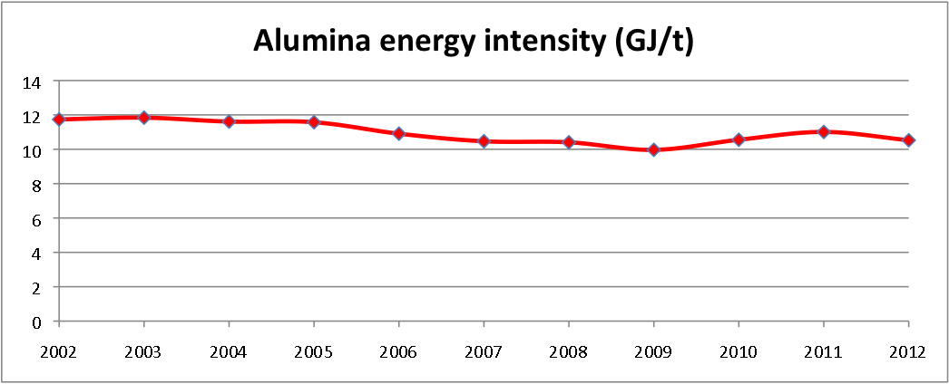

Figure 3. Aluminium electricity intensity

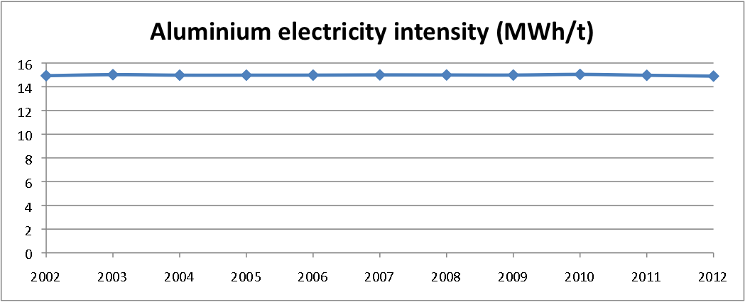

In the alumina refining sector, reductions in energy intensity over the period 2005 to 2009 were the result of expansions of existing refineries and the construction of the Yarwun refinery in Gladstone. Increases in energy intensity in the period 2009 to 2011 were the result of reduced production due to commercial constraints and external factors (eg. floods).

In the aluminium smelting sector, the facilities and production levels were relatively constant over the period with the exception of the closure of one smelter late in 2012.

The data shown in the graphs demonstrates a number of points around energy efficiency in industrial processes:

* Due to the pre-existing focus on improving energy efficiency within the sectors, there is no ‘low hanging fruit’ available for immediate investment, nor would such an investment necessarily stack up in a   
  whole-of-business approach to improving the viability of these facilities.
* Any ‘breakout’ improvement in energy efficiency would most likely only come from greenfield or brownfield expansion, which would allow the introduction of new processing facilities with lower levels of energy intensity.
* The EEO program has not had any noticeable impact on improving energy efficiency within this sector.

## Upstream Oil & Gas Industry

The upstream oil and gas industry is one of Australia’s most capital-intensive industries and invests in   
long-life assets, designed to last for many decades.

Australian oil and gas companies have in place longstanding and pervasive energy management policies, systems and measurement indicators that form a core part of their operational performance. A clear example of these existing drivers can be found in the operations of Australia’s two export LNG plants:

* the North West Shelf Venture (NWSV), located in the north-west of Western Australia; and
* Darwin LNG, located at Darwin in the Northern Territory.

The process of liquefying natural gas for export as LNG, known as liquefaction, is very energy-intensive. The fuel used to power the various processes at LNG facilities is derived from the source natural gas. Any gas used to serve a feedstock is gas that cannot be liquefied and then sold to export customers. This means that the use of natural gas as an energy source at the LNG facility has a very direct opportunity cost associated with it, in that every unit of gas that can be saved through reducing energy use, is a unit of gas that can be sold.

This commercial driver to conserve gas pervades the initial design, technology choice and ongoing operation of these facilities, and exists independent of any government regulation. Similar drivers exist for other upstream oil and gas facilities, producing crude oil and condensate, or gas for domestic use.

Projects of this nature and magnitude are designed to utilise the most efficient and cost-effective technology available at the time of construction. The history of the NWSV, for example, shows that as each LNG train has been constructed, step change advances in energy intensity, energy efficiency and GHG emissions reductions, have been achieved. Figure 4 shows a comparison between LNG intensity ‑ tonnes of carbon dioxide equivalent (CO2-e)/tonne of LNG ‑ for a number of operating and committed conventional Australian LNG projects.

Figure 4. LNG Intensity: Selected operating and committed Australian LNG projects



*Source: Chevron Australia (2009)*

While this is a chart of emissions intensity and not energy efficiency, the impact of new trains on relative performance is clear, with the start-up of NWSV Train 4 in 2004 and of NWSV Train 5 in 2008 having a marked effect on CO2-e emissions intensity. This is a result of the new technology employed in Trains 4 and 5, as these trains are processing similar natural gas and are located in a similar environment. The relative intensity of the Darwin LNG facility, which commenced production in 2006, is also evident.

The construction of the single LNG train at Darwin saw several advances in the evolution of LNG liquefaction technology. The Darwin LNG plant, for example, uses high efficiency, low emission,   
aero-derivative gas turbines as refrigerant drivers, and utilises waste heat recovery on the gas turbine exhaust for various heating requirements within the plant. Similar improvements are expected in the new facilities under construction, and could also be expected for the other possible LNG projects under consideration around Australia.

This indicates that the major opportunities for step change energy efficiency for large-scale capital-intensive investments in the upstream oil and gas industry, come at the initial investment stage or when major expansions take place. In both cases, significant drivers for energy efficiency already exist to ensure the most efficient investments are undertaken:

* **Internal:** Companies have formal internal approval processes for project developments that require evaluation of best available technology options against energy efficiency or carbon efficiency criteria, amongst others.
* **Market-based:** The price that can be achieved for the saleable product produced at the facility (the direct opportunity cost of energy usage).

## Electricity Generation Industry

The electricity generation sector converts one form of energy into electricity. As such, energy efficiency is its principal business activity, not a secondary cost-saving opportunity.

Energy efficiency within electricity generation is generally constrained by two closely related inputs: (i) available feedstock, and (ii) choice of technology. In a competitive wholesale market, such as the National Electricity Market (***NEM***), market prices signals and forward contracts indicate the type of capacity (base‐load or peak) that is required to meet demand efficiently. Potential investors make commercial decisions based on the relative merits of different technologies to meet these market conditions.

New generation investment to meet growing demand has occurred in the NEM, with about 1000MW added per year since its inception in 1999. The Bureau of Resources & Energy Economics estimated that the total gross fixed capital value of electricity supply assets in 2011 was approximately $11.3 billion[6].

Throughout the design, tender and procurement phase of a potential new project, equipment manufacturers work closely with the buyer to identify the particular technology that best suits the operational characteristics of the plant, to satisfy market needs. For example, an investor in a gas turbine project will examine options looking at capacity, operating flexibility, thermal efficiency and emissions intensity, scope to upgrade from open cycle to combined cycle or combined heat and power, reliability, trade‐offs in maintenance costs and capital costs, and a host of other factors. These decisions are complex and multi-faceted as the asset is likely to have a life of 40+ years.

Investment in electricity generation requires substantial financial outlays. For example, capital costs are estimated to be:

* $5+ billion for a four unit 2,000MW black coal‐fired station.
* $1+ billion for a 1,000MW combined cycle gas‐fired power station.
* ~$1 billion for a 420MW wind farm development.

In comparing different fuel types and technologies, an investor must consider the significant trade‐offs between upfront capital costs and ongoing operating and maintenance costs.

The Australian Energy Regulator’s (***AER***’s) 2012 State of the Energy Market report[7], highlights that from the beginning of the NEM in 1999 until June 2012, around 13,200MW of new generation investment has occurred, as shown in Figure 5. Tightening supply conditions led to an upswing in investment in 2008/9 and 2009/10, with over 4,100MW of new capacity added. This new capacity comprised predominantly gas‐fired generation in New South Wales and Queensland, and wind farms in South Australia and Victoria, in response to the large‐scale mandatory renewable energy target (***RET***). However, subdued electricity demand and surplus capacity have resulted in flat investment over the past 2 years, with only 1,350MW of new capacity added (one third of this was wind generation subsidised by the RET). In addition, weak demand and the wide range of climate change policies contributed to about 3,000MW of coal plant in 2012 being shut down or periodically offline.

Figure 5. Annual investment in registered generation capacity[8]



Figure 6. Major proposed generation investment – cumulative, June 2012[9]



Looking forward, the AER has identified over 32,500MW of proposed generation investment in the NEM (Figure 6). However, the AER concedes that many of these projects are speculative, and investments will either be deferred or cancelled based on current demand forecasts. Almost all of the proposals rely on gas‐fired and wind technologies.

The power generation sector has very significant levels of sunk capital, and asset owners have every incentive to maximise their return on investment. New plant has been built over the last 13 years, based on clear market signals and available technology aligned to feedstocks. The plant is costly and long-lived, and poor investment decisions cannot be easily reversed, particularly if the investment is sunk. Any recommendations to retire equipment before the end of its operational life may require significant asset write-downs with associated profitability impacts.

Existing plans must be efficient to survive. Short-term equipment and process changes are difficult and costly to implement, and often have wider consequences. With falling wholesale prices, for example (as shown in Figure 7 for NSW, on the following page), there is every incentive for energy producers to seek options to maximise their efficient operation to increase margins in these difficult operating conditions. Regulations such as the EEO do not support these asset owners, but rather add to the cost of operation through the administrative burden.

The options are limited given that fuel switching for coal-fired generation to gas is not feasible, due to the shortage of gas and rising prices. As new technology cannot be justified, the end result is the mothballing of plant with the hope that market conditions will improve.

Figure 7. Mean demand and average wholesale prices in NSW[10]

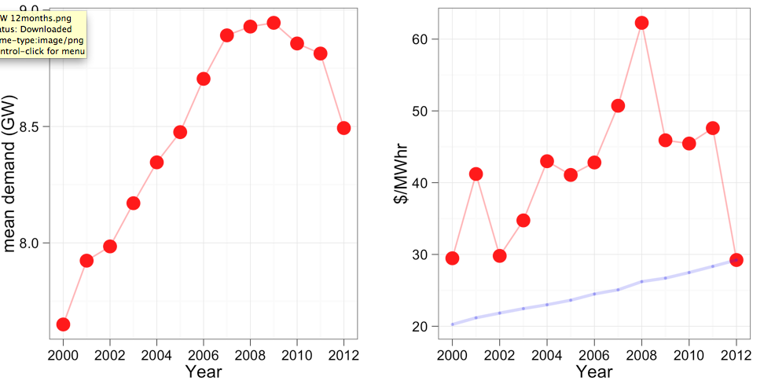

# Framework Principles for Future Energy Efficiency Policy

Australia needs to ensure that it has a comprehensive and coherent national energy policy that drives the development of our energy resources, supports a strong energy export industry, and provides for the reliable and efficient delivery of competitively-priced energy to households and businesses. AIGN welcomes the opportunity the Government has provided to input into the development of an Energy Whitepaper noting that energy efficiency is identified as an issue for which the Government seeks feedback.

A policy that narrowly focuses on reductions in the use of energy implies that the use of one factor of production (energy) can be minimised without regard to the corresponding cost trade-offs. Such an approach may translate into lower growth for the Australian economy.

There are many reasons an energy efficiency gap (as perceived by third parties) may be less than assumed, including:

* existence of hidden costs;
* uncertainty about future energy savings; and
* particular characteristics of energy efficiency investments.

Over recent decades there have been a large number of energy efficiency measures imposed by national, state/territory and local governments. The major program with implications for AIGN members is the [EEO program](http://www.ret.gov.au/energy/efficiency/eeo/Pages/default.aspx). Introduced in 2005, the EEO program requires corporations that use more than 0.5PJ of energy to identify and assess energy efficiency opportunities, and subsequently report outcomes of these assessments both publicly and to the government. AIGN members have reported that the unduly prescriptive nature of the EEO incurred high administrative and implementation costs (in the order of several million dollars).

AIGN supports the decision in the 2013/14 Mid Year Economic and Fiscal Outlook to terminate funding for the EEO program from 1 July 2014, and the recognition in the Energy Whitepaper Issues that for many companies, energy prices and the desire for cost reduction, business improvement strategies and corporate targets, are substantially more compelling drivers in motivating energy management in comparison with regulatory requirements.

While it is acknowledged that there are limits to the adoption of energy efficiency measures, AIGN does not support the interpretation that these limits are evidence of market failure and, therefore, do not believe that there is necessarily a role for government intervention within the industry sector. Many of the issues highlighted in this paper reflect rational internal decision-making, taking into account economic costs and risk assessments.

Government policies and programs that are implemented in the absence of market failure or that do not address the underlying market failure specifically, run the risk of encouraging irrational decision-making. This is particularly the case when the form of intervention is obligatory and prescriptive.

While AIGN members support the general aspiration of minimising energy use, it is important to understand that value creation is not necessarily achieved by focussing on one metric only. Business must have the flexibility to maximise shareholder value. Governments can support business by setting national goals and policy frameworks that allow individual businesses to respond, without overly prescriptive mandates that can create perverse outcomes.

From industry’s point of view the formula for a step change in energy efficiency is relatively straightforward:

***A competitive industry = a profitable industry***

***A profitable industry =investment and replacement of capital stock***

***Investment = new energy efficient technology***

***New technology = step-change in energy efficiency***

AIGN has recommended the development of a national approach towards climate change policy that is consistent with other policy objectives such as the economy, employment, trade, investment, technology, environment and regional and rural development. . Intervention should only occur where there are clear instances of market or information failure The lack of a nationally integrated program creates considerable additional complexity and costs for industry, particularly for national businesses, due to the plethora of different rules and regulations imposed by different jurisdictions.

It is important to stop the fragmented policy development in relation to energy, including renewable energy, energy efficiency, and climate change mitigation. A comprehensive overarching policy framework is required; a framework that is coherent with our national economic goals and one that recognises Australia’s international standing.

AIGN suggests the following principles for a national energy efficiency policy, under a national energy policy (which also encompasses a national climate change mitigation policy):

* Australia will strive for an effective global response to climate change.
* Polices are stable, predictable and avoid complexity to help minimise investment uncertainty and are developed and implemented transparently to engender community support
* Policies do not expose Australian export and import competing industry to costs not faced by these industries in other countries
* Effective coordination across federal and state agencies to support policy development and implementation and keep administrative costs low, with lower compliance and transaction costs for industry, while maximising the potential benefits arising from energy production and energy efficiency improvements.
* Energy policies should be consistent with other national policies including on economic growth, population growth, international trade, energy supply and demand and environmental and social responsibilities
* Policies aimed at reducing emissions and improving energy efficiency should distribute the cost burden fairly across the community.
* No disadvantage to early movers that have previously taken action to reduce emissions or be more energy efficient, or discrimination against new entrants.
* Target the source of poor market outcomes or market failures.
* Programs that support information-sharing and recognition of industry achievements.
* Maximise flexibility for business and minimise regulatory impacts.

Following the above policy principles, the Government’s approach must recognise that the industrial sectors are well placed to identify, assess and prioritise energy efficiency investment opportunities, but such decisions are multi-faceted; commercial decision-making must not be distorted by government intervention requiring prescribed responses.

# Conclusion

AIGN members are large energy producers and large energy users. Controlling energy costs in these operations is critical to maintaining the competitive viability of the businesses in domestic and international markets. Industrial emissions intensity within Australia has improved over recent years in response to rising energy prices, which have triggered decisions and investment to improve profitability (and, in many cases, result in energy efficiency gains).

Decisions on investments around energy use are one of many that a firm will need to balance with regard to any investment options requiring capital to realise. Focussing on energy efficiency whilst ignoring other important inputs will not necessarily result in the most efficient use of energy resources. Furthermore, such an approach ignores the underpinning profitability of a business and is therefore unviable.

Investment (and hence production) decisions are driven by the combined costs of all inputs and best reflect a firm’s perspective of the economic environment and their competitiveness within it. As the Report highlights a policy that narrowly focuses on reductions in the use of energy implies that the use of one factor of production (energy) is minimised without sufficient regard to the corresponding cost trade-offs. Economic efficiency relates total costs to the value of the output that those costs generate, and it is this metric that underpins decision-making in business.

The Report also highlights that companies are focussed on the efficiency of capital in an environment where there are limits on the capital available for investment, and also increasing global competition for investment both in existing and new facilities.

AIGN has recommended the development of an integrated national energy policy. This policy should incorporate both a national climate change mitigation policy and a national energy efficiency policy. It is imperative that state and territory policies are well aligned with the national policy to maximise benefits and minimise compliance costs. AIGN has recommended a set of principles for the development of such a national energy efficiency policy.

With increasing energy costs in recent years, the strong commercial incentive for organisations to minimise their energy use has been clearly understood on operating sites as well as in boardrooms. Saving energy saves money – at least most of the time. It is not a truism for all businesses or in all situations. This is why commercial decision-making must take account of the specific operating environment, and governments cannot prescriptively mandate businesses focus on only one element of their business.

Improvements in energy efficiency can create wider benefits, but the decision-making must reside with the business that owns the assets and is tasked by shareholders to balance a wide range of regulatory, commercial and technical requirements. Large energy producers and users, including export and import competing companies, have complex decision-making processes and need to weigh a wide range of factors; energy efficiency outcomes are just one such factor.

Limits to improvements in energy efficiency are real, and not simply information failures. Companies have limits on the capital available for investment, and often hurdle rates for energy efficiency improvements are set to reflect process disruptions, risk to achievement, and resources required.

AIGN has recommended the development of an integrated national energy policy. Within this policy should be both a national climate change mitigation policy and a national energy efficiency policy. It is imperative that state and territory policies are well aligned with the national policy, to maximise benefits and minimise compliance costs. Companies in the industrial sectors have found that programs such as the EEO are unduly prescriptive, administratively burdensome, and the benefits are very limited. AIGN has recommended a set of principles for the development of such a national energy efficiency policy.

AIGN members remain willing to work with governments to further develop these ideas. Governments can best support investment in industrial business efficiency by providing a stable industrial, energy and climate change policy environment in which policy risks are minimised.

1. <http://www.climateworksaustralia.org/sites/default/files/documents/publications/climateworks_trackingprogress_overview_july2013.pdf>, p18.
2. Ibid., p18.
3. “Garnaut Review Update”, *Update Paper 8: Transforming the Electricity Sector*, 29 March 2011, <http://www.garnautreview.org.au/update-2011/update-papers/up8-key-points.html>.
4. AFGC, *Impact of a Carbon Tax Survey*, July 2013, <http://www.afgc.org.au/tools-guides-.html>.
5. Australian Industry Group, *Ai Group Survey: Business Picks Up Carbon Tax Bill*, June 2013, <http://www.aigroup.com.au/portal/binary/com.epicentric.contentmanagement.servlet.ContentDeliveryServlet/LIVE_CONTENT/Publications/Reports/2013/Carbon%2520Tax%2520report%2520FINAL.pdf>, p1.
6. DRET, Bureau of Resources & Energy Economics, *Energy in Australia 2012*, February 2012.
7. AER, *State of the Energy Market 2012*, <http://www.aer.gov.au/sites/default/files/State%20of%20the%20Energy%20market%202012%20-%20Complete%20report%20%28A4%29.pdf>
8. Ibid., Figure 1.20, p51.
9. AER, *State of the Energy Market 2012*, <http://www.aer.gov.au/sites/default/files/State%20of%20the%20Energy%20market%202012%20-%20Complete%20report%20%28A4%29.pdf>, Figure 1.22, p54.
10. RenewEconomy*,* [*Our power prices are plunging, but only for a chosen few*](http://reneweconomy.com.au/2012/our-power-prices-are-plunging-but-only-for-a-chosen-few-95471)*,* 5 June 2012<http://reneweconomy.com.au/2012/our-power-prices-are-plunging-but-only-for-a-chosen-few-95471> (graphs supplied by Professor Mike Sandiford, Melbourne Energy Institute).